

**Electrical Specifications:**

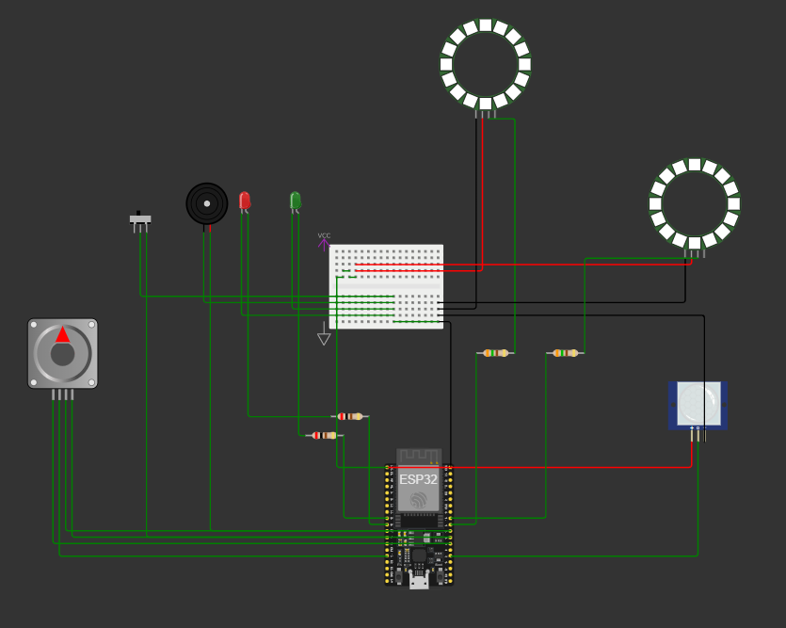

**The Circuit:**

An ESP32-devkit-c-v4 is used as the microcontroller. We have a stepper motor which is configured to take n (configured) steps clockwise and anticlockwise. Two LEDs – Red and Green indicate Access Mode of door. Only Red=HIGH indicates Restricted entry while Only Green=HIGH indicates Allowed entry. The access mode is controlled by a switch which will be fixed inside the room. The alarm system consists of a buzzer and Red-Blue Oscillatory Neo Ring LED along with a white LED fixed outside the room. In case of alarm trigger, the white LED will reduce darkness when a fixed camera takes burst photos and a small video near the door. These media can be sent via a Cloud-IOT integration to owner’s device. All this motion is detected by a PIR sensor. A breadboard is implemented – The upper rail is a 3v3 VCC while the lower rail is GND. The resistors used are 250 ohms for LEDs while 350 Ohms for ring Led.

The Working Circuit (Without IOT) can be accessed here:

<https://wokwi.com/projects/397584346285034497>

The Theoretical Circuit Code (With Arduino IOT cloud integration) can be accessed in the Without IOT folder of Arduino IDE Codes folder.

**FUNDAMENTAL WORKING:**

The PIR Sensor continuously senses the motion.

If Access Mode = Allowed: (GREEN=HIGH RED=LOW)

The esp32 activates stepper motor. This motor turns the gears of the Hypogean Gear System which opens/closes the door.

If Access Mode = Restricted: (GREEN=LOW RED=HIGH)

The door if senses anything waits for 5 seconds, then both RED=HIGH and GREEN = HIGH simultaneously occurs. Another 5 sec wait, then if PIR Sensor Value = 1, then the buzzer is activated along with a Neo Ring Led RB Oscillating alarm light and a White LED to help camera capture burst photos and small video to be sent to the owner through Cloud IOT integration. The esp32 will always be connected to the wifi in the room or a separate sim to wifi converter may be connected to esp32.

**Mechanical Specifications:**

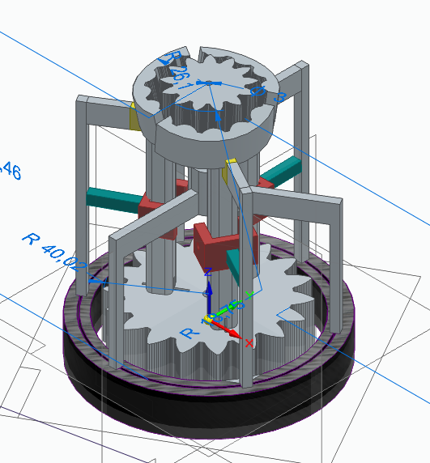

The stepper motor will turn this Hypogean Gear System which will be fit coaxially underground below door’s hinge. The door will have no handle/lock. This Hypogean Gear System comes with a specialized break pad – gear system.

The uppermost (target gear) has a coaxial break pad which prevents opening/pushing of door. The lowermost gear is connected to the stepper motor while the tri-groove contains a spring which is connected to 3 approacher rods. When it turns, the centrifugal force will cause the approacher rods to tilt towards the central axis, thus causing the approaching gears to come together and thus cause an activator gear mechanism. The cyan-red colored elements are pivots for the rods. The entire external system on black rail will revolve with the lower gear system. The central axis will have an actuator, activated by esp32 to retract the brake pads before putting stepperMotor = HIGH. For accessmode=Restricted, The brake pad will block the upper gear rotation and giving us a strong locking cum auto-door system.

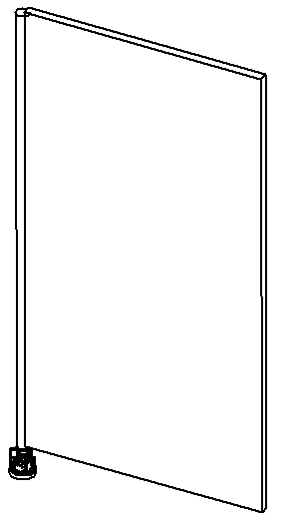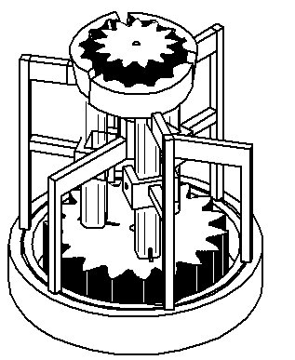

This Hypogean Gear System will go underground and a Cylindrical monohinge wil go coaxially above target gear and the door will be inserted inside this cylindrical hinge.